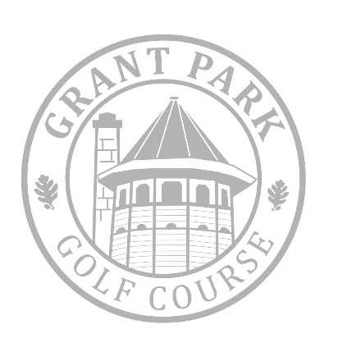
2025 Summer Scramble

Grant Park Golf Course – Saturday, July 19th – 8:00am Shotgun

FORMAT: 4 PERSON SCRAMBLE: Pays 1st, 2nd, 7th, and Two Wild Card Spots

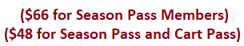
$100 per golfer
INCLUDES EVERYTHING!!!
Price Includes:
$3000+
In Prizes (w/ Full Field)
*GOLF and CART
*Lunch
*1 BEVERAGE VOUCHER
*ENTRY INTO THE MEGA RAFFLE
*FLAG EVENTS
*TEAM PRIZES

Field is limited to 80 players (20 teams). First come first serve! SIGN UP NOW!

Player #1___________________________ Player #2 _______________________________

Player #3___________________________ Player #4 _______________________________

Contact #: __________________________ Email: ________________________________

If you have any questions: (414) 762-4646 or Michael.Zirtzlaff@milwaukeecountywi.gov

*Reserve your spot today by replying to my email. Thanks,
Michael Zirtzlaff
Head Golf Professional

