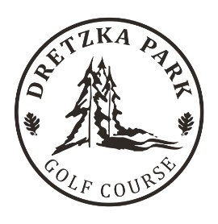
2026 Dretzka Park FALL Junior Golf
August 27th through September 24th

Junior Name:________________________________________________
5:30pm to 6:45pm
Parents Name:______________________________________________
Phone Number:______________________________________________
Email:_______________________________________________________
Emergency Contact:_________________________________________
Notes: ex) Allergies,etc.. ______________________________________________________________
______________________________________________________________
______________________________________________________________
Payment: $150 per child - Cash, Check, Venmo or Paypal
Venmo - @David-Labinski
Paypal – biggolfer77@gmail.com

My Contact Information
David Labinski, PGA Head Golf Professional Dretzka Park
Work Phone: 414-354-7300
Cell Phone: 414-559-0085
Email: David.labinski@milwaukeecountywi.gov

